**Sentiment Analysis of Social Media Campaigns - Entertainment Sector**

Pooja Joshi & E.Code [E25007]

# **Overview :**

# The objective of this report is to outline the progress and findings related to the sentiment analysis of social media campaigns within the entertainment sector. This analysis focuses on understanding audience reactions and engagement through sentiment scores derived from social media interactions.

# **Objective:**

· To analyze sentiment trends over time and their relationship with audience engagement metrics.

· To derive insights that can inform marketing strategies and enhance viewer acquisition efforts.

# **Assigned Task(s) :**

· **Sentiment Analysis of Social Media Campaigns**

· **Data Visualization for Trends**

# **Task Details :**

**Task 1: Sentiment Trend Analysis**

* **Status:** In Progress
* **Details:** Analyzed the sentiment scores from social media data, focusing on the compound scores to identify trends over time. Data was visualized to understand how sentiment correlates with audience attendance and engagement.

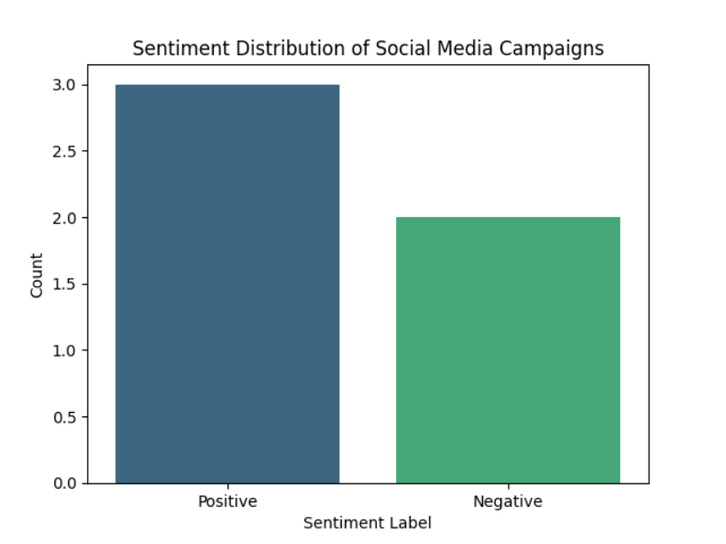

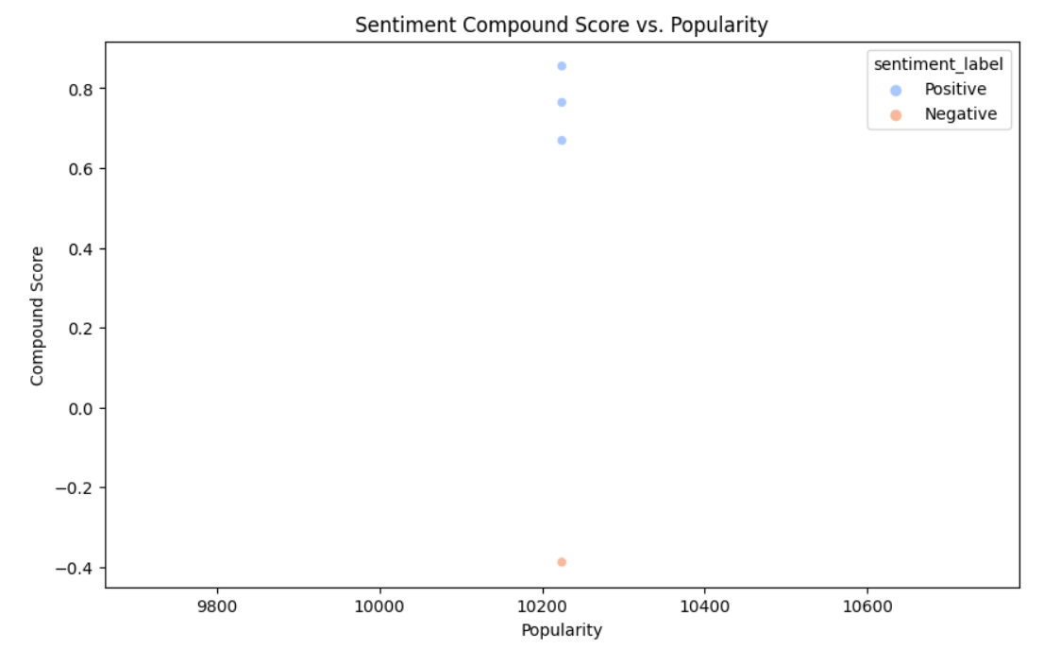

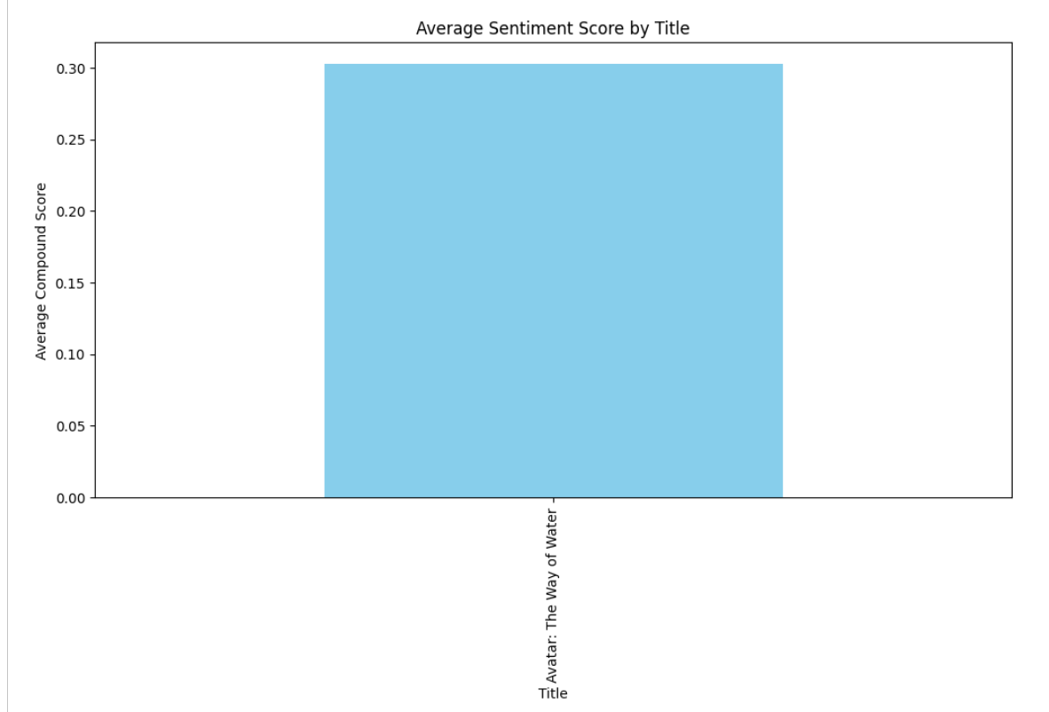

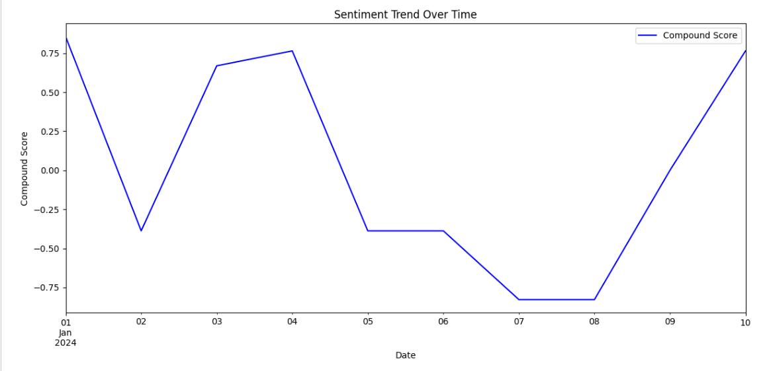

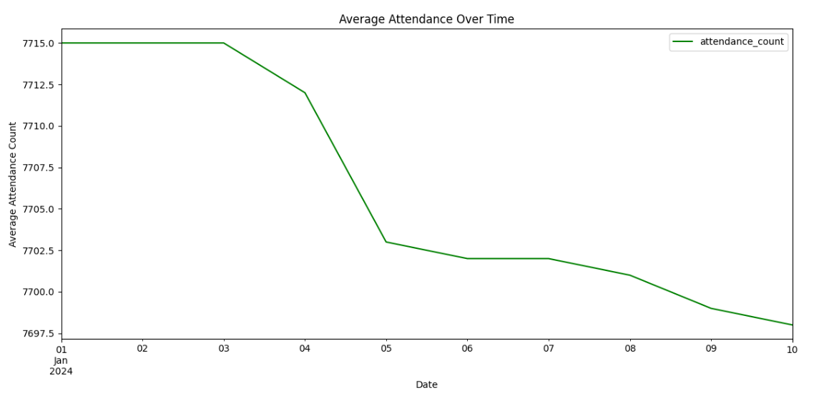

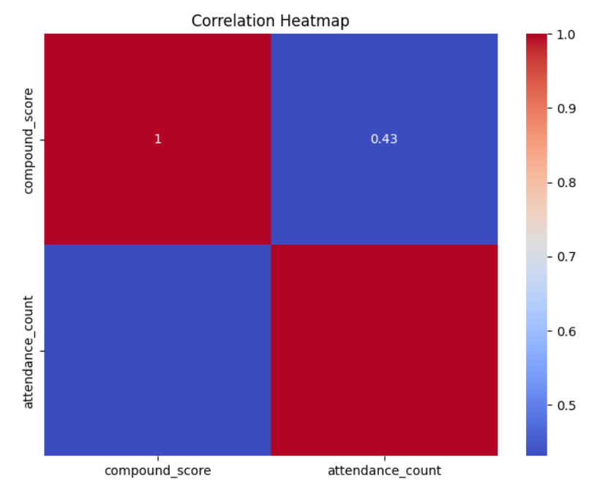

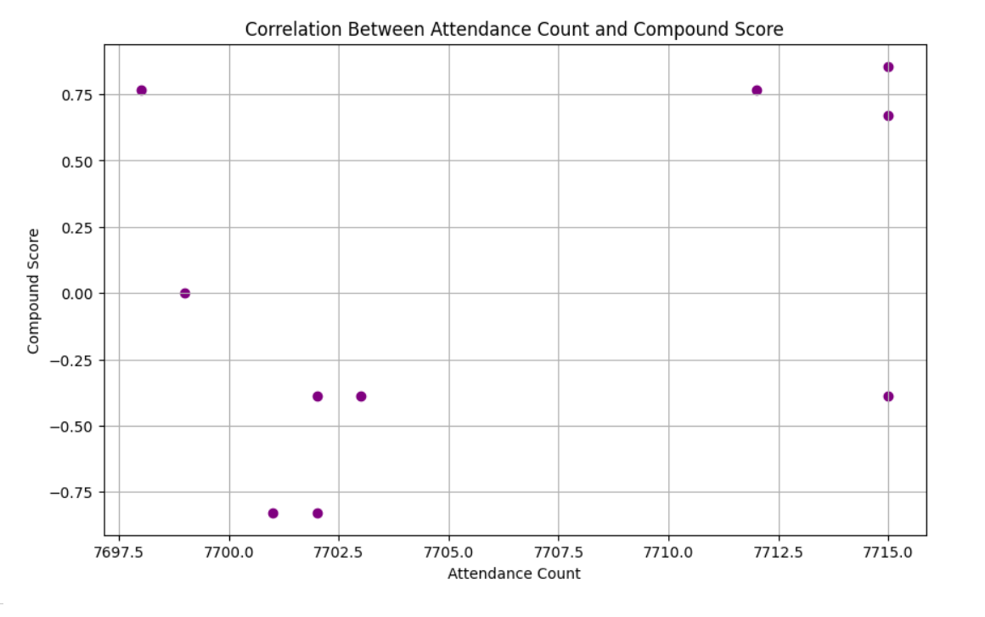

**Progress :**

· ****Accomplishments:****

* Successfully implemented sentiment trend visualizations using Python's matplotlib library.
* Developed a clear understanding of how sentiment correlates with attendance metrics.

·  ****Metrics:****

* The compound sentiment score showed a strong correlation with audience attendance, indicating that positive sentiments may lead to higher viewer acquisition.

# **Challenges and Solutions :**

**· **Challenges Faced:****

* Encountered difficulties in extracting and preprocessing data effectively, leading to errors in visualization.

**· **Solutions Implemented:****

* Improved data cleaning procedures and ensured that the date columns were correctly formatted for analysis. Resolved errors in visualizations by verifying the DataFrame structure.

**Next Steps :**

**· **Upcoming Tasks:****

* Complete the analysis of viewer acquisition costs and its relation to marketing efforts.
* Continue to refine sentiment analysis methods and incorporate additional data sources.

**· **Goals:****

* Aim to finalize the sentiment analysis report by the end of the week, including comprehensive insights and recommendations.

# **Conclusion :**

### **Summary:**

* The sentiment analysis has provided valuable insights into audience engagement with social media campaigns. The relationship between sentiment scores and attendance metrics highlights the importance of positive audience perception.

# · **Acknowledgments:** Thank the audience for their time and attention.